VMW 261 Final exam

NAME ____________________

SCORE ______/40

**Part 1 – Multiple choice (20 points)**

1. Which of these rootstocks is likely to be the least drought tolerant?
   1. Riparia Gloire (*V. riparia*)
   2. Kober 5BB (*V. berlandieri X V. riparia*)
   3. 110R (*V. berlandieri X V. rupestris*)
   4. 420A (*V. berlandieri X V. riparia*)
2. You take a soil test and petiole analysis at bloom time. The soil test shows a pH of 4.9 and low Phosphorus. The tissue results show low phosphorus and you are starting to see phosphorus deficiency in your vineyard. What might be the most appropriate course of action?
   1. Apply lime to make more P available in the soil
   2. Apply foliar Phosphorus to ameliorate the current deficiency
   3. Apply lime and foliar phosphorus
   4. Apply kelp and BD 501
3. Which of these soils tests is unreliable?
   1. pH
   2. Phosphorus
   3. Potassium
   4. Nitrogen
4. A deficit this nutrient will first be apparent in the older leaves.
   1. Calcium
   2. Boron
   3. Magnesium
   4. Sulfur
5. At what point is vine N uptake by the roots the highest?
   1. Budbreak
   2. Bloom
   3. Veraison
   4. Harvest
6. What might you use to fertilize with Magnesium and raise soil pH at the same time?
   1. Agricultural lime
   2. Dolomite
   3. Gypsum
   4. Epsom salts
7. What is true of the following fertilizer:

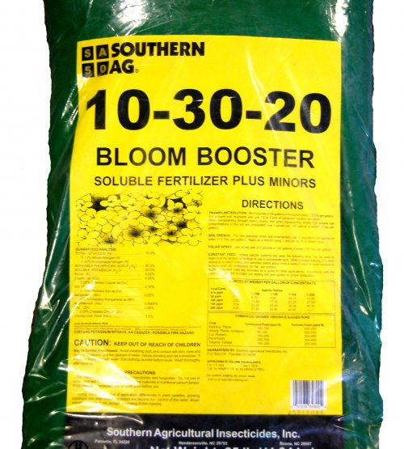

* 1. It contains 10% Phosphorus by weight
  2. It contains 30% Nitrogen by weight
  3. It contains 20% Phosphorus by weight
  4. It contains 10% Nitrogen by weight

1. You decide to eschew good taste and grow grapes in Napa Valley. You want to plant on a soil that is derived from Serpentine parent material with high Mg++ and Ca++. What may happen?
   1. Excellent root growth with 101-14 rootstock
   2. Poor root growth with 101-14 rootstock and the need for a rootstock like 44-53 or St. George
   3. Low soil pH
   4. Potassium excess
2. Pruning to too few buds could lead to_____________
   1. Double shoots
   2. Water shoots
   3. Suckers
   4. All of the above

1. What is a possible consequence of leaving more buds per vine?
   1. Less berries per cluster and smaller berries
   2. Less berries per cluster and larger berries
   3. No change in cluster size or berry size
   4. Longer rachis
2. What is a possible treatment for Bunch Stem Necrosis?
   1. Potassium sprays in the fruit zone before veraison
   2. Magnesium sprays in the fruit zone before veraison
   3. Phosphorus sprays in the fruit zone before veraison
   4. Regulated Deficit Irrigation before veraison
3. Xylem water inflow accounts for ________ of water in the berry.
   1. 25%
   2. 50%
   3. 75%
   4. 100%
4. Xylem water inflow to the berry ______________
   1. Ceases at fruitset
   2. Ceases at veraison
   3. Ceases at commercial harvest
   4. Doesn’t stop
5. A winemaker in Walla Walla wants to harvest Syrah at 28oBrix. What is the potential alcohol of this wine if a water addition is not made?
   1. 11%
   2. 12%
   3. 17%
   4. 19%
6. Potassium _________________
   1. Influences berry pH by forming crystals with tartaric acid
   2. Influences berry pH by displacing H+ protons and hindering malic degradation
   3. Doesn’t influence berry pH
   4. Forms crystals with Ca++ in the berry
7. TDN______________
   1. Is a terpene that confers petrol-like aromas in Riesling
   2. Is a norisoprenoid that confers floral aormas in Semillon
   3. Is a terpene that confers floral aroams in Riesling
   4. Is a norisoprenoid that confers petrol-like aromas in Riesling
8. Heat and sunlight
   1. Can lead to less accumulation and greater degradation of methoxypyrazines
   2. Can lead to greater accumulation and less degradation of methoxypyrazines
   3. Can lead to less accumulation and greater degradation of norisoprenoids
   4. Can lead to less accumulation and greater degradation of C6 aldehydes
9. For which variety are thiols not likely a major contributor to varietal aroma?
   1. Petit Manseng
   2. Sauvignon blanc
   3. Riesling
   4. Chardonnay
10. Mature leaves start_________
    1. At about 1 or 2 leaves from the most recently unfolded leaf
    2. At about 4 – 6 leaves from the most recently unfolded leaf
    3. At about 100 days after first unfolding
    4. At the shoot tip
11. The phloem
    1. Is responsible for moving carbohydrates, amino acids and nutrients around the vine
    2. Is very sensitive to water deficits
    3. Is where glucose and fructose is transported through the plant
    4. Is not used for translocation

**Part 2 - Free answer (20 points)**

1. You have an 8 acre farm and you want to broadcast 50 lb N/acre. You want to use urea (46:0:0). Urea costs $25/bag (50 lb bag). How much will the fertilizer cost you? (Hint: you can’t buy a fraction of bag). (5 points)

𝑙𝑏/𝑎𝑐𝑟𝑒 𝑜𝑓 𝑓𝑒𝑟𝑡𝑖𝑙𝑖𝑧𝑒𝑟 = 𝑙𝑏/𝑎𝑐𝑟𝑒 𝑜𝑓 𝑛𝑢𝑡𝑟𝑖𝑒𝑛𝑡 ÷ ( % 𝑜𝑓 𝑛𝑢𝑡𝑟𝑖𝑒𝑛𝑡 𝑖𝑛 𝑓𝑒𝑟𝑡𝑖𝑙𝑖𝑧𝑒𝑟 ÷ 100)

* 1. Why does TA decrease during ripening? (3 points)
  2. You are growing in high Potassium soils in a warm climate. You want to retain more of your acid for sparkling wine production. What are 2 ways in which you might achieve this goal? (2 points)

1. You have clone 90 Pinot noir and it is having trouble setting fruit. The clusters have a considerable amount of shatter and are coming in with an average cluster weight of 50 grams/cluster (PN is normally ~90 – 130 grams/cluster). You have been applying complex micronutrients and your tissue analyses don’t indicate any nutritional issues. How might you improve fruitset of this clone? What managerial/operational issues might arise from this course of action? (2 points)
2. You are growing Sauvignon blanc in the Willamette Valley. The wine you are producing is pretty bland and lacks “varietal character”. You would like to increase the concentration of the tropical thiols, but you’re not too keen on the green aromas that come from methoxypyrazines. What vineyard practices might you use to increase the concentration and perception of thiols, whilst diminishing the concentration and perception of methoxypyrazines in your Sauvignon blanc? (8 points).